**Memcached – A tried-and-true caching solution for your web applications.**

*In the day and age,we live in, having a web application is a necessity not only for businesses but also for anyone who wants to share useful information with the world. Nothing is more frustrating than a slow web application. Suppose if your web app takes forever to load, then what’s the point of having an awesome web app in terms of its other elements?*

*There’s a reason for everything that happens. The major reason that’s effecting the web applications speed is the database load. The process goes like, each time new requests are being made to the server, the more time it will take to load a website or a web application.*

*Any possible solution to work on this issue? Yes.*

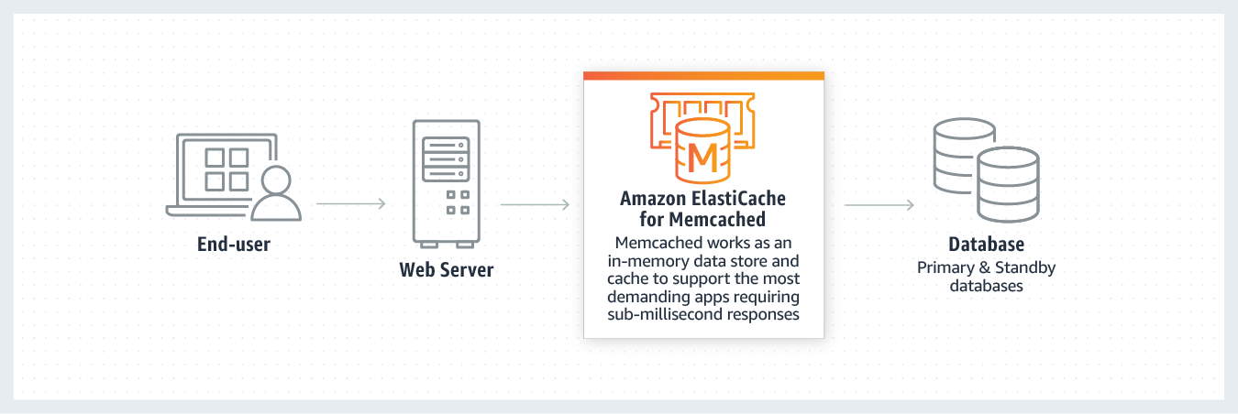

*Having the proper caching mechanisms in place is one of the most important things you can do to speed up the delivery of the website. Caching is something that refers to the process of storing static files such as HTML documents, media files, images etc for easier and faster access so that the database does not have to retrieve each and every file every time. One such memory caching system is Memcached.*

*As we already know, every time a database request is made it adds additional load to the server. In simpler terms, Memcached reduces that load by storing data objects in dynamic memory (say shortterm memory for applications). To be much clear, it stores data based on key values for small arbitrary strings or objects including:*

*1. Results of database calls. 2. API calls 3. Page rendering.*

*Working Mechanism Of Memcached:*

*1. The client requests a piece of data which Memcached checks to see if it is stored in cache. 2. Two possible outcomes are:*

*1.If data is stored in cache:*

*Returns the data from Memcached.(no need to check the database)*

*2.If data isn’t stored in cache:*

*It queries the database, retrieves the data, and stores it in Memcached.*

*3.Whenever information is changed or the expiry value of an item has expired, Memcached updates its cache to ensure fresh content is delivered to the client.*

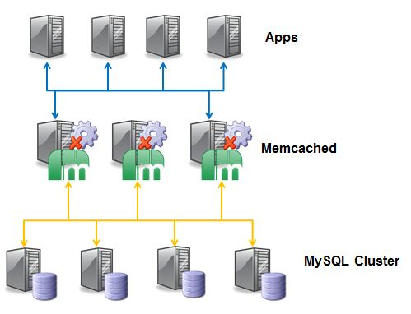

*Few important points about Memcached architecture :*

*Data is only sent to one server.*

*Servers don’t share data.*

*Servers keep values in RAM – if RAM runs out the oldest value is discarded.*